Detecting Brute Force Attack on Security Onion
As part of my ongoing cyber defense and threat detection lab at codeessence, I investigated brute force attemtp on security onion using zeek, kibana, and suricata.

Objective
Identify signs of brute force or repeated unauthorized login attempts by analyzing Zeek and Suricate a with Security Onion.

Detection Evidence
Logs Analyzed: zeek.conn, zeek.ssh, suricata
Event type: Multiple SSH connection attempts
Protocol: TCP

From zeek.conn:
source.ip: 203.161.44.39
destination.ip: 203.161.44.208
destination.port: 22
connection_state.description: connection attempt rejected
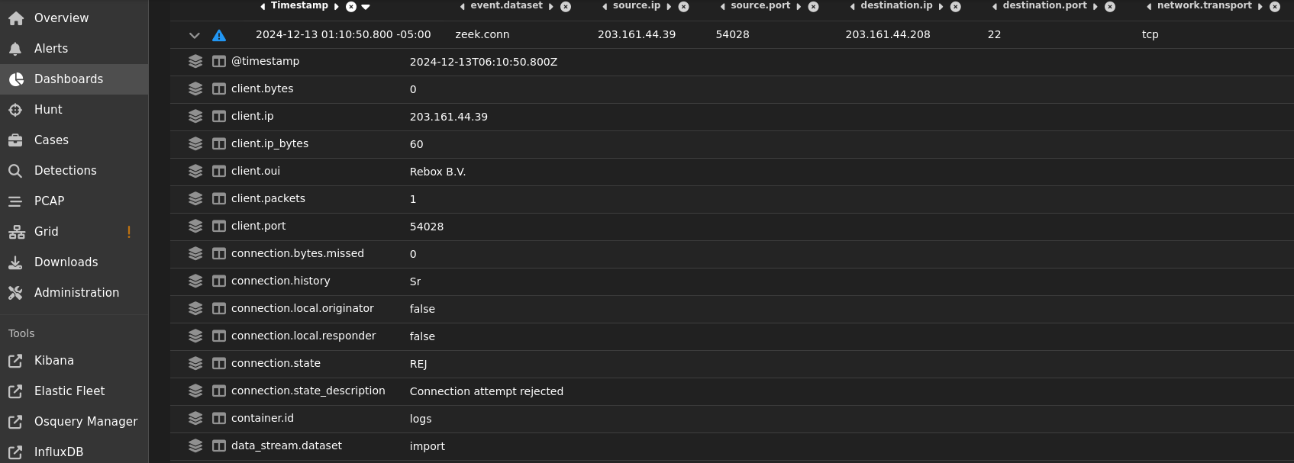

Pattern Observed:
Dozen of repeated SSH connection attempts from the same external IP (203.161.44.39) to internal host (203.161.44.208) within a short time window.
All connection were marked as rejected, indicating unsuccessful connection attempts.
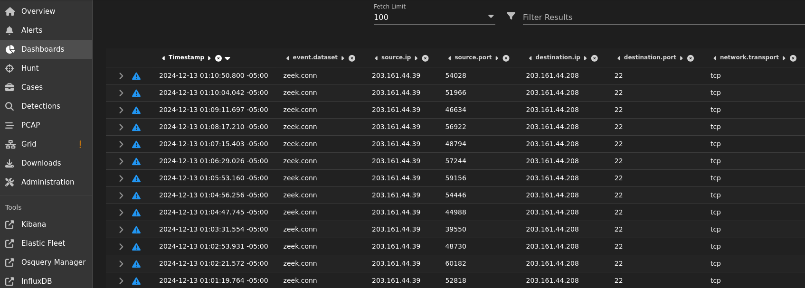
Analysis:
The logs display rapid repeated SSH connection attempts without successful handshakes. This pattern is consistent with:
- Automated brute-force or credential-guessing activity
- Scanning tools probing open SSH ports
Although no successful logins were recorded, the persistence and repetitiion are clear signs of unauthorized access attempts.
Supporting Indicators:
- High frequency of connection attempts in a short duration
- Cosistent destination port
- Rejected state -- showing defensive measures

Conclusion:
This activity represents a potential SSH brute force reconnaissance attempt.
The attacker (203.161.44.39) likely scanned or attempted to brute force credentials on the target (203.161.44.208), but all attempts were denied.

Severity: Medium
Impact: Low (no compromise detected)
Likelihooed: HIGH

Recommendations:
- Block offending IP (203.161.44.39) at the firewall or IPS
- Restrict SSH access -- allow only specific trusted IPs or use VPN.
- Enable rete limiting on SSH to deter brute force attempts.
- Correlate with Suricata alerts for SSH or login related anomalies.
- Monitor for follow up attempts or successful login from the same source

Takeaway:
Even when unsuccessful, repeated “connection attempt rejected” events in Zeek logs can uncover early of brute force or scanning activity
Detecting these patterns early helps prevent escalation to credential compromise or lateral movement.

Tools Used:
Security Onion, Zeek, Suricata, Kibana, cURL
Tags:
#CyberSecurity #ThreatDetection #brute-force #WebSecurity #SecurityOnion #Zeek #Suricata #DVWA #BlueTeam

